**สมุนไพรไทยตำรับ“ยาแคปซูลเคอร่า” ในการยับยั้งไวรัสไข้หวัดใหญ่**

Thai herbal formula "Kerra Capsules" in inhibiting the influenza virus

เกียรติทวี ชูวงศ์โกมล1 และ ผุสดี สระทอง2*

1ภาควิชาชีวเคมี คณะวิทยาศาสตร์ ม. เกษตรศาสตร์ และ 2วิทยาลัยพยาบาลพระจอมเกล้า จังหวัดเพชรบุรี

**Corresponding Author**: ผุสดี สระทอง E-mail: pussadee10@yahoo.com

**บทคัดย่อ**

โรคระบาดเป็นภัยที่ทำลายมนุษยชาติมาอย่างยาวนาน ตั้งแต่ยุคโบราณจนถึงปัจจุบัน ประเทศไทยเป็นหนึ่งในประเทศที่สามารถผ่านวิกฤตต่างๆ มาได้ด้วยการใช้สมุนไพร โดยเฉพาะสมุนไพรจากตำรับตักกะศิลา การแพร่ระบาดของโรคติดเชื้อไข้หวัดใหญ่เกิดขึ้นในทุกปี ยังคงมีความรุนแรงทำให้เสียชีวิตได้ ในบางกรณี จนส่งผลกระทบต่อระบบสาธารณสุขอย่างมาก ทั้งในด้านบุคลากรและเวชภัณฑ์ ในงานวิจัยนี้ การใช้ยาสมุนไพรไทยจากตำรับตักกะศิลา ซึ่งผ่านการทดลองทางคลินิกว่าปลอดภัยและมีการขอขึ้นทะเบียน ยาสมุนไพรตำรับนี้ ทะเบียนเลขที่ G40/50 และชื่อจดทะเบียนว่า “ยาแคปซูลเคอร่า” จากกระทรวงสาธารณสุข มีสารประกอบโมเลกุลขนาดเล็กที่แสดงผลการรักษาต่อการยับยั้งการทำงานของเอนไซม์ neuraminidase และยับยั้งการเข้าเซลล์ของไวรัสไข้หวัดใหญ่ H1N1 ในระดับห้องทดลอง ซึ่งงานวิจัยนี้ควรมีการพัฒนาต่อยอดการวิจัยทางคลินิกเพื่อนำผลที่ได้ไปใช้ประโยชน์ในการรักษาผู้ติดเชื้อไวรัสไข้หวัดใหญ่ ในอนาคต

Abstract

Epidemics have been a threat to humanity for a long time, from ancient times to the present. Thailand is one of the countries that has managed to overcome various crises through the use of herbal medicine, particularly herbs from the Takasila formula. The outbreak of influenza infections occurs every year and remains severe, causing fatalities in some cases, which significantly impacts the public health system in terms of personnel and medical supplies. In this research, the use of Thai herbal medicine from the Takasila formula, which has been clinically tested for safety and registered, is explored. This herbal medicine, registered under number G40/50 and known by the trade name "Kerra Capsules" by the Ministry of Public Health, contains small molecular compounds that have shown efficacy in inhibiting the activity of the neuraminidase enzyme and blocking the entry of the H1N1 influenza virus into cells in laboratory studies. This research should be further developed through clinical trials to utilize the findings for treating influenza virus infections in the future.

**Introduction**

Herbal medicine is Thai wisdom that has been passed down from generation to generation for more than 2,000 years. According to the herbal plant database, Thailand has over 1,800 types of beneficial local herbs (Department of Academic Affairs, Ministry of Education, 1999) and has a long history of being used for treating diseases. The treatment of severe fevers according to the Takasila scriptures involves seven different herbal formulas, ranging from the first to the seventh formula. The first formula is "Ya Kaeo 5 Duang" (Five Roots Medicine), followed by the second formula, "Ya Prasa Phiw Phai Nok" (External Skin Medicine), the third formula, "Ya Phon Phai Nok" (External Spray Medicine), the fourth formula, "Ya Phon and Ya Kin" (Spray and Oral Medicine), and the fifth formula, "Ya Prae Khai" (Fever Transforming Medicine), which includes 11 ingredients. The sixth formula is "Ya Phon Prae Phiw Phai Nok" (External Skin Transforming Spray Medicine) with 4 ingredients. The seventh formula, called "Ya Khrop Khai Takasila" (Takasila Fever Encompassing Medicine), consists of 14 ingredients: red sandalwood, benzoin resin, leaves of Sauropus androgynus, eaglewood, bulb of Scilla, roots of Gac, agarwood, leaves of Swada, roots of Cissus quadrangularis, lemon leaves, white sandalwood, roots of Chionanthus retusus, Tinospora crispa vine, and Shorea flowers. The treatment involves regular consumption until recovery (Department of Academic Affairs, Ministry of Education, 1999). The "Ya Khrop Khai Takasila" or the seventh formula is widely used, especially during epidemics involving fever. Vetchakorn Osot has modified this herbal formula by replacing some currently rare herbs such as agarwood, eaglewood, Sauropus androgynus leaves, Swada leaves, and Cissus quadrangularis with Tinospora crispa, which has properties to reduce fever, expel phlegm, prevent and treat infections, reduce inflammation, boost immunity, increase strength, and slow aging. Various parts of Tinospora crispa contain antioxidants. The formula is encapsulated to ensure comprehensive efficacy, high stability, and compliance with modern medical principles (Vetchakorn Osot, 2021). This KERRA has evidence against COVID-19 virus and HEPES virus. Therefore it is interesting to investigate that it has effect against influenza too.

**Research methodology**

1. Anti H1N1 virus assay

MDCK cells were seeded in a 96-well plate at a concentration of 20,000 cells per well and incubated overnight. The cells were then treated with Kerra at concentrations ranging from 1,000 to 1.56 micrograms per milliliter for 1 hour. After the incubation, H1N1 virus was added at an MOI of 100 and incubated for another hour. Following this, the virus was washed off, and 200 microliters of cell culture medium were added. The cells were then cultured for 3 days. After the incubation period, the cells were fixed with formalin and stained with crystal violet. Images were then recorded.

1. Anti neuraminidase assay

Neuraminidase assay was done according to Neuraminidase Assay Kit from MERCK (catalogue number MAK121) Prepare the Master Reaction Mix as outlined in Table 1, with 80 μL allocated for each Sample, blank, and Standard reaction well. Add 80 μL of the respective reaction mix to each well and ensure thorough mixing, either using a horizontal shaker or pipetting, followed by incubation at 37°C while shielding from light. After 20 minutes, measure the absorbance of Samples and Standards at 570 nm for colorimetric assays or λex = 530/λem = 585 nm for fluorometric assays to determine M20 min. Extend the incubation for an additional 30 minutes at 37°C before measuring absorbance again at the same wavelengths to determine M50 min.

**Table 1.**

| Reaction Mixes **Reagent** | **Sample and Standards** | **Sample blank** |
| --- | --- | --- |
| Assay Buffer | 30 μL | 85 μL |
| Substrate | 55 μL | – |
| Cofactors | 1 μL | 1 μL |
| Enzyme | 1 μL | 1 μL |
| Dye Reagent | 0.5 μL | 0.5 μL |

**Results**

The tests showed that Kerra could inhibit H1N1 influenza virus infection. At a concentration of 1,000 micrograms per milliliter, Kerra was able to completely inhibit infection in MDCK cells, compared to cells that were not treated with Kerra, as shown in Figure 1. The percentage of infection gradually increased as the concentration of Kerra decreased.

รูปภาพประกอบด้วย ข้อความ, ตัวอักษร, ภาพหน้าจอ, แผนภาพ

คำอธิบายที่สร้างโดยอัตโนมัติ

Figure 1: Graph showing the percentage of H1N1 virus infection in MDCK cells treated with various concentrations of Kerra.

For mechanism of this Kerra, the neuraminidase enzyme was tested against the crude extract. The result showed that Kerra might inhibit virus infection via inhibition of neuraminidase enzyme as shown in Figure 2. The result also showed that does dependent inhibition of Kerra against neuraminidase 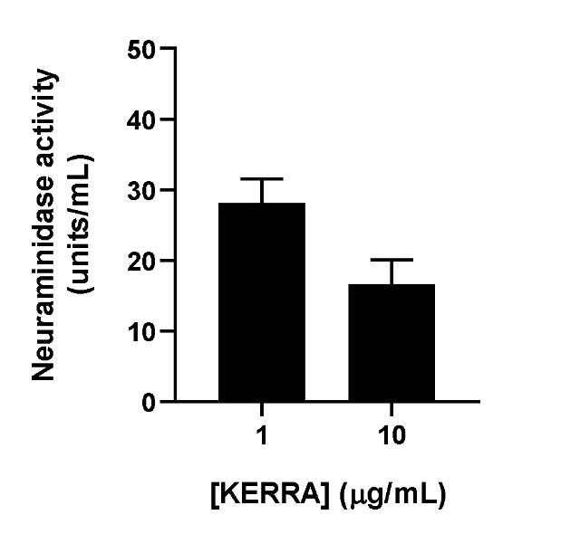

Figure 2: Graph showing the activity of the neuraminidase enzyme at concentrations of 1 and 10 micrograms per milliliter of Kerra.

**Conclusion**

The experiment found that Kerra at a concentration of 1,000 micrograms per milliliter effectively inhibited H1N1 influenza virus infection in MDCK cells. Additionally, in the neuraminidase activity test, it was discovered that Kerra at a concentration of 10 micrograms per milliliter was more effective in reducing the activity of the neuraminidase enzyme compared to a concentration of 1 microgram per milliliter.

**References**

Choowongkomon, Kiattawee, Khuanjarat Choengpanya, Chamsai Pientong, Tipaya Ekalaksananan, Sulak Talawat, Pussadee Srathong, and Jureeporn Chuerduangphui. 2023. "The Inhibitory Effect of KerraTM, KSTM, and MinozaTM on Human Papillomavirus Infection and Cervical Cancer" *Medicina* 59, no. 12: 2169.

Department of Academic Affairs, Ministry of Education. (1999) *Textbook of medical science : medical wisdom and the literary heritage of the nation.* Bangkok. (In Thai)

Seetaha, Supaphorn, Phatcharin Khamplong, Panatda Wanaragthai, Thitinan Aiebchun, Siriluk Ratanabunyong, Sucheewin Krobthong, Yodying Yingchutrakul, Jatuporn Rattanasrisomporn, and Kiattawee Choowongkomon. 2022. "KERRA, Mixed Medicinal Plant Extracts, Inhibits SARS-CoV-2 Targets Enzymes and Feline Coronavirus" *COVID* 2, no. 5: 621-632.

Vetchakorn Osot. (2021). Kerra Capsule. 2014. Available at: <https://www.kerraherb.com/> (Accessed: 1 March 2021) (in Thai).